[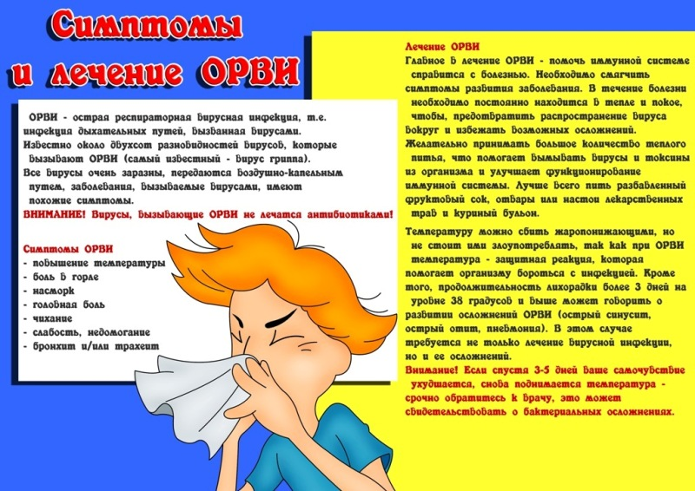](http://www.google.com/url?sa=i&source=images&cd=&cad=rja&docid=GdJb5ynCpjbMwM&tbnid=JMc_2MDh55E9bM:&ved=0CAgQjRwwAA&url=http://09.rospotrebnadzor.ru/directions_of_activity/profilaktika/obzor/-/asset_publisher/Cwx8/content/%D0%BF%D0%B0%D0%BC%D1%8F%D1%82%D0%BA%D0%B0-%D0%BF%D0%BE-%D0%B3%D1%80%D0%B8%D0%BF%D0%BF%D1%83-%D0%B8-%D0%BE%D1%80%D0%B2%D0%B8;jsessionid%3D26EC14CFB3045E11147C224FD2C38496?_101_INSTANCE_Cwx8_redirect%3Dhttp%3A%2F%2F09.rospotrebnadzor.ru%2Fdirections_of_activity%2Fprofilaktika%2Fobzor%3Bjsessionid%3D93A4B22A1FBE728790D3A011B253BD9C%3Fp_p_id%3D101_INSTANCE_Cwx8%26p_p_lifecycle%3D0%26p_p_state%3Dnormal%26p_p_mode%3Dview%26p_p_col_id%3Dcolumn-1%26p_p_col_count%3D1&ei=muB5UsvTI-nV4gSx3ICQCg&psig=AFQjCNHSXtEgoQEAtFqdMQRH3wZIXuwJIQ&ust=1383805466614900)